DID YOU KNOW???
REVERSE ANGLE PARKING SAFER THAN TRADITIONAL DIAGONAL PARKING
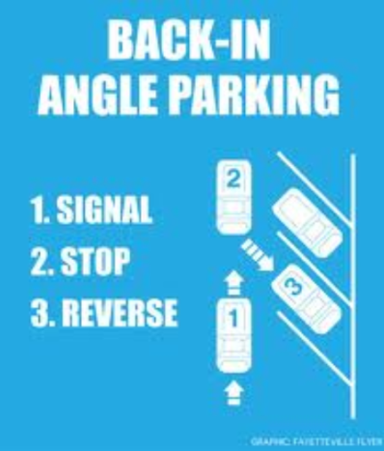
Reverse angle parking is a safer type of angle parking and is being used throughout the United States and, beginning with the start of school, is being used in some sections of the parking areas at St. Joseph’s School in Malone. Instead of pulling into the parking spot, cars back into their spots, allowing them to make eye contact with oncoming traffic when exiting the parking space.
To properly execute reverse angle parking, follow these three simple steps illustrated by the accompanying diagram.
- First, signal a right turn to warn drivers behind you.
- Second, pull past the parking spot and stop.
- Third, reverse into the parking spot.
The biggest benefit of this parking strategy is much better visibility by the driver when exiting the parking space. As you can see, the driver is positioned in the left front of the car, with much better visibility of traffic traveling along the street or the parking lot when preparing to exit. In the traditional method, the driver would be on the wrong side of the car and furthest away from traffic that he/she must yield to upon leaving the parking place. Where this parking method has been in use, there have been a decreased number of collisions, as motorists no longer have to back out blindly from their space.
Further, there is improved safety for children and for cyclists. Car doors open in a manner that directs children to the back of the vehicle, ushering them towards the sidewalk of grass area rather than the street or the middle of the parking lot. For cyclists, as vehicles exit their parking stall, they are better able to see cyclists in the roadway. Tucson, AZ, reported an average of 3-4 bike/car crashes per month before back-in angled parking. In the four years following implementation, there were none.
Another benefit of reverse angle parking is that it does not require as much space to maneuver as traditional angle parking.
There can be some negatives to reverse angle parking. Vehicles can overhang sidewalks. This is not normally a major issue and can be overcome with proper design and placement. Another negative is vehicles backing into street furniture or signs. Again, this can be overcome.
When Plattsburgh tried reverse angle parking on Miller St., in the vicinity of the post office, vehicles attempted to enter spaces head-in from the opposite side of the street. This problem can be alleviated with enforcement, signs, and driver education.
As noted above, reverse angle parking is safer than traditional diagonal parking. However, traffic safety experts recommend not backing up at all unless there is no alternative. Try to find a parking space where you can drive in when parking and when you return to your vehicle drive forward to exit. In a situation where this is impossible, it is better to back in when parking and drive out when leaving. This is especially true when parking at an event where a large number of people will be leaving at the same time, like a theater or sporting event.
Think of this as “first move forward”. When returning to your vehicle, your first move should be forward. You may find it awkward at first, but after some practice, it will be easy.
For more articles on traffic law and safety, go to the traffic safety board’s web site at: www.franklincony.org and click on “Traffic Safety Board” under departments then look for Did You Know articles under “services”.

